Crystal Products

E-Project

Design Guide

Group Members

|  |  |
| --- | --- |
| Enrollment ID | Name |
| Student1417420 | Abdullah |
| Student1417817 | Rumaisa Adnan |
| Student1418200 | Muhammad Umair Taufiq |
| Student1395567 | Abdul Wasay |

**Group:** A

**Curriculum:** 7062

**Semester:** CPISM

**Supervisor:** Sir Shahryar

**Certificate of Recognition**

A certificate of recognition for crystal products is a formal document that acknowledges and certifies the quality and authenticity of crystal products. It is typically awarded to manufacturers, suppliers, or retailers of crystal products who have demonstrated excellence in producing or selling high-quality and authentic crystal products.

The certificate of recognition may include details such as the name of the manufacturer or supplier, the type of crystal products produced or sold, and the criteria for which the certificate was awarded. It may also include the date of the certificate's issuance and a signature from an authorized representative of the awarding organization.

A certificate of recognition for crystal products can help to establish credibility and trust with customers, as well as differentiate a business from competitors. It may be awarded by industry associations, trade organizations, or other reputable bodies that have established criteria for assessing the quality and authenticity of crystal products.

Presented on: 24-FEB-2023

Authorized Signature: ______________________________

**Acknowledgements**

We would like to express our sincere gratitude to everyone who has contributed to the successful completion of this project.

Our heartfelt thanks go to **Sir Shahryar** for providing invaluable guidance and support throughout the entire process.

We are deeply grateful to our colleagues and team members for their hard work, dedication, and collaboration. Their efforts have been instrumental in bringing this project to fruition.

We would also like to thank our families for their love and support, which has allowed us to stay focused and motivated.

Finally, we extend our thanks to all those who have provided us with the resources and opportunities necessary to complete this project.

This project would not have been possible without the help and support of all of you. Thank you.

**Synopsis**

Crystal products are items made from crystal, a highly transparent and reflective material that is valued for its beauty and clarity. Crystal is a type of glass that is made from a mixture of silica, lead oxide, and other elements, which gives it its unique properties. Crystal is often used to create decorative items such as vases, figurines, and chandeliers, as well as functional items such as stemware, bowls, and pitchers. Crystal products can be found in a variety of styles and designs, from classic and traditional to modern and contemporary. They are available at various price points, depending on the quality of the crystal and the complexity of the design. Some of the most popular crystal brands include Waterford, Swarovski, and Baccarat.

**Problem Statement**

Today, people are drawn to crystals for a number of reasons, including primarily that

they are very beautiful objects and their different shapes, sizes and colours have

proved fascinating and mysterious as well.  They can be found in various forms of

beautiful jewellery, or on their own in rough uncut specimens that are sometimes

used as ornaments to decorate homes.

Crystals are used to enhance the body&#39;s own healing abilities, reduce stress and

improve the quality of your life. They hold a massive amount of energy and those

who work with them believe that they have their own individual energy field or

personality.

Holding crystals or placing them on your body is thought to promote physical,

emotional and spiritual healing. Crystals supposedly do this by positively interacting

with your body&#39;s energy field, or chakra. While some crystals are said to alleviate

stress, others purportedly improve concentration or creativity

A need is felt to develop a site which will give all necessary information and also will

list the various products. The website is to be developed based on following

requirements.

Requirement Specification:

The Web site is to be created based on the following requirements.

There should be pages as mentioned below

1. Home

2. About Us

3. Special Offers

4. New Arrival

5. Products

6. Contact Us

1) The Home Page should be created making use of Sections with a suitable

logo, the header section can be added which will show images of various

products.

2) The site must contain the links to navigate through any category for the

information.

3) The site should display a menu which will contain the options for brief

introduction about the various products available, location of the shop and

any other information if required.

4) The information should be categorized according to the various crystals like if

a User wants to see only “Diamond/Amber/Amethyst etc” products then

he/she can click on a Link/button/menu etc and can see only that crystal

products.

5) When a user selects any particular crystal, a list of all the products for that

crystal will be displayed

6) A brief summary of features of the product should be displayed on the Web

Page along with the picture but detailed Features should be stored in

Individual Word documents which can be downloaded or viewed by the User

who wishes to see the same.

7) The user should also be able to compare the various products

8) There should be a “Contact Us” page which will have the Address of the

Company which should be displayed using GeoLocation API (eg. GoogleMaps)

and the email address which when clicked will invoke the local mail client

from where they can send an email.

Navbar

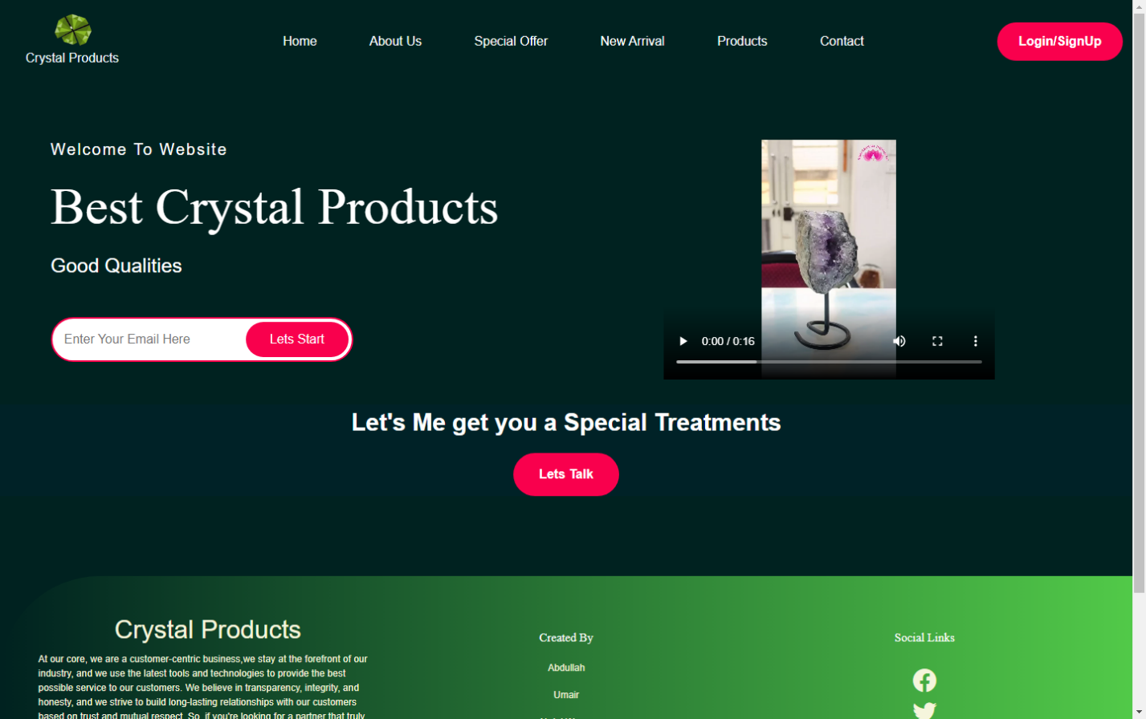

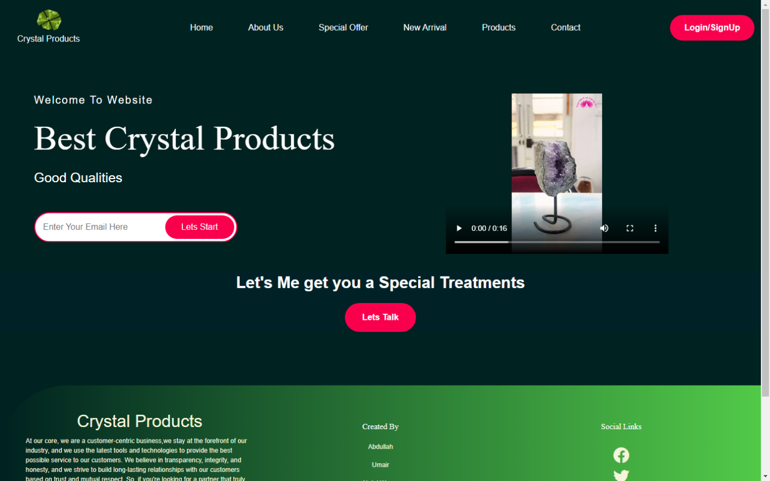Hero Section

Footer

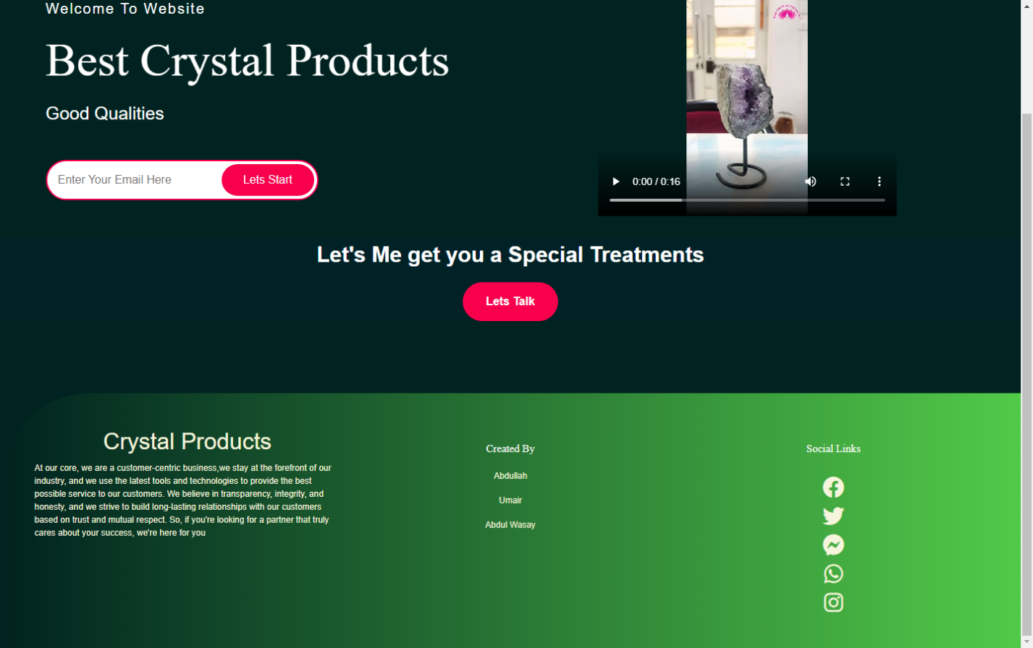

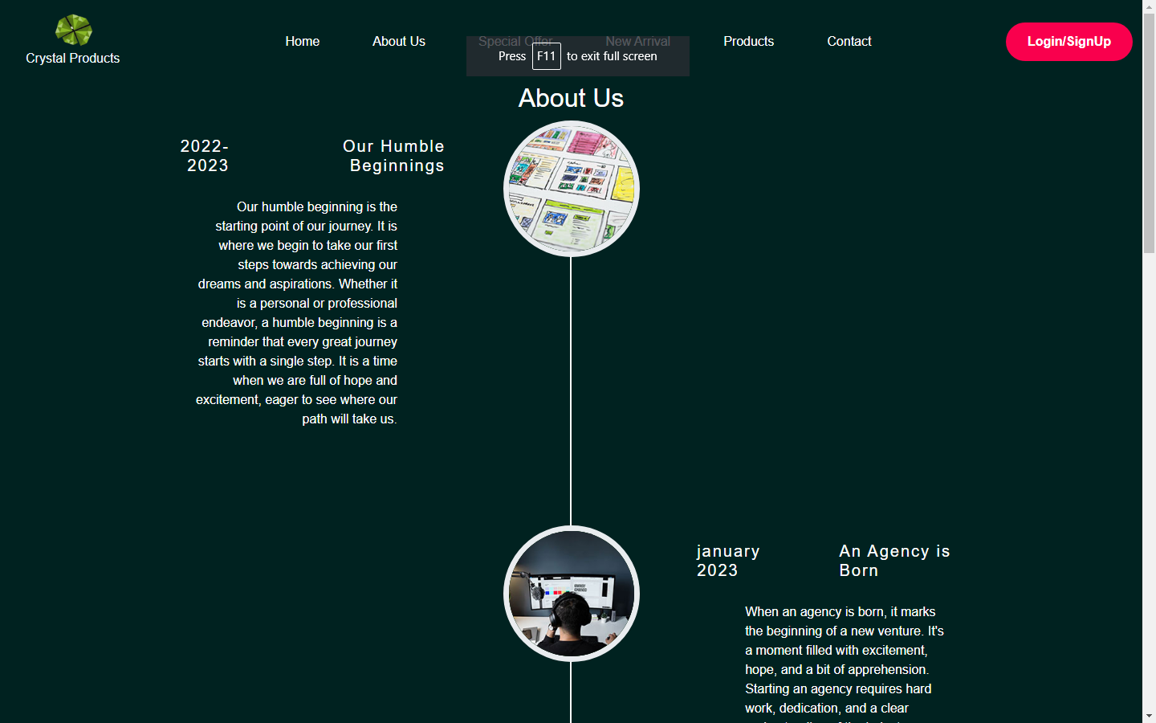About Us

About Us

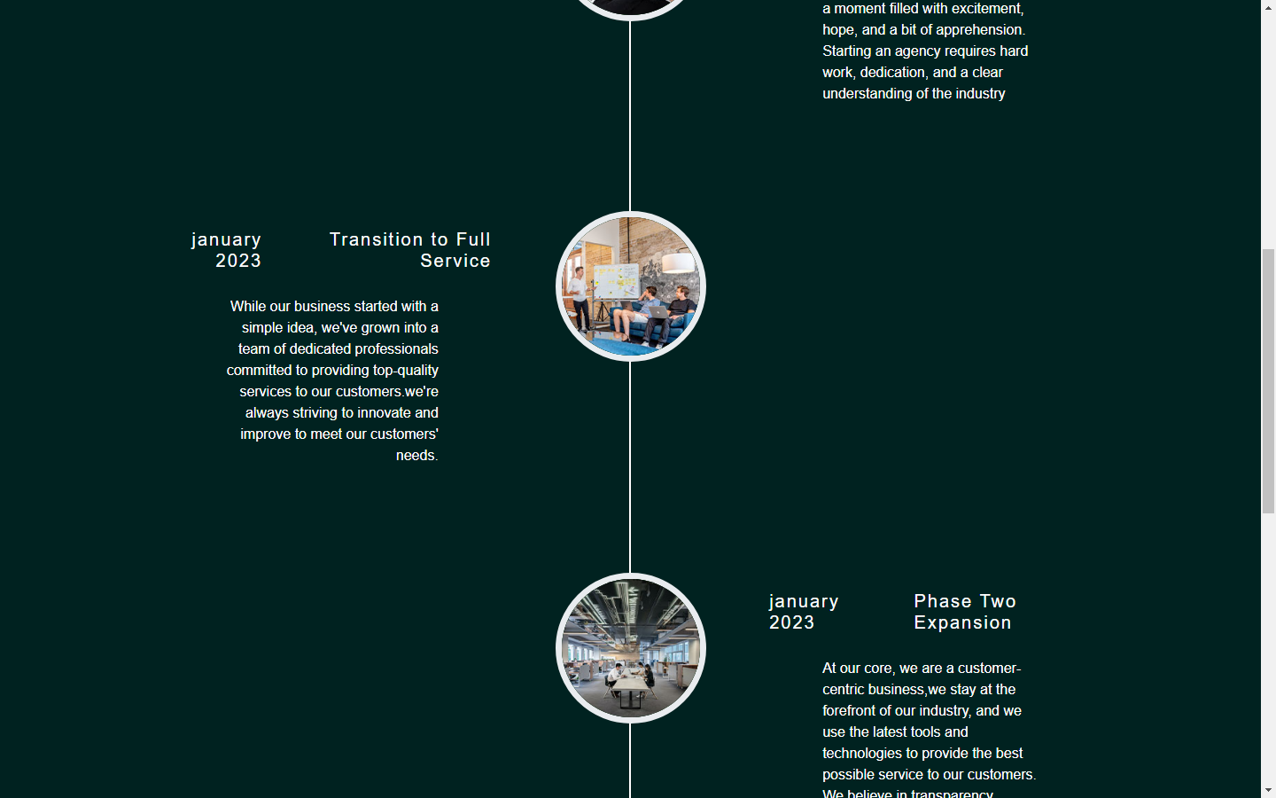

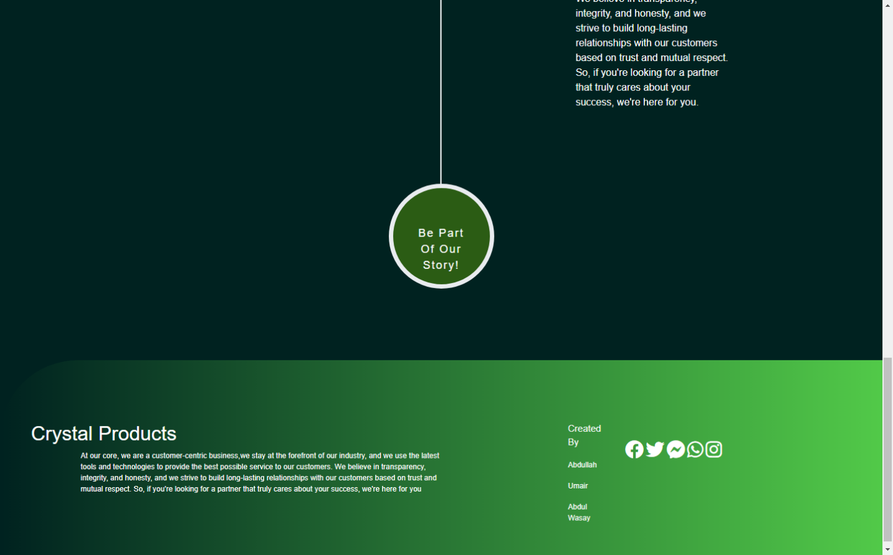

Special Offer

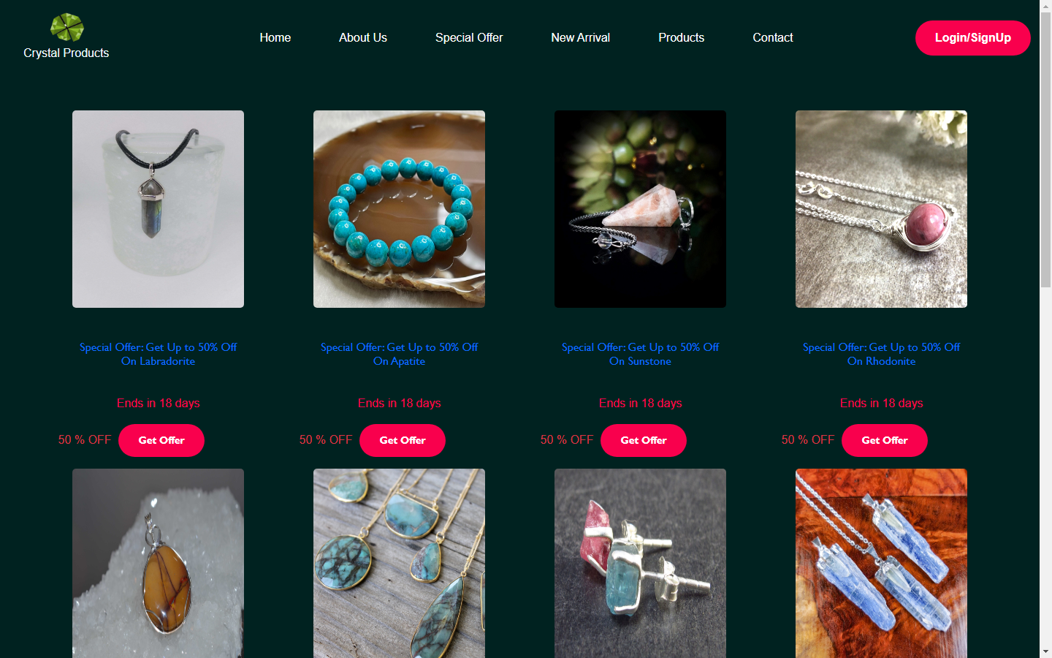

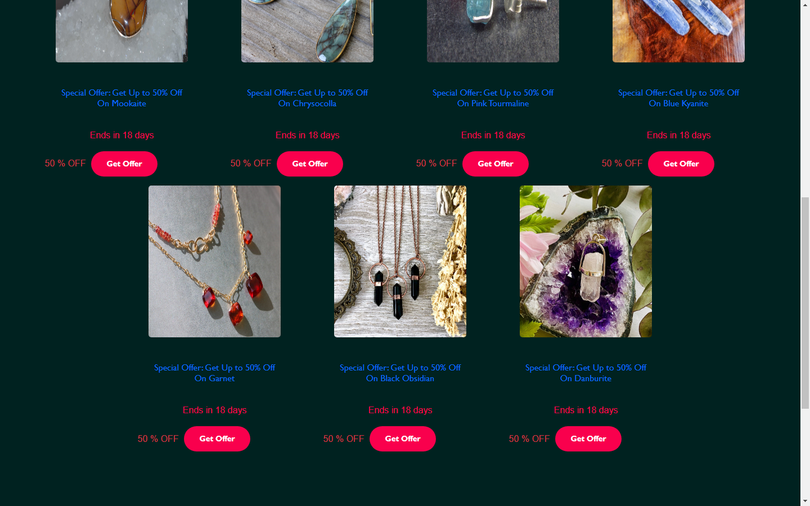

New Arrivals

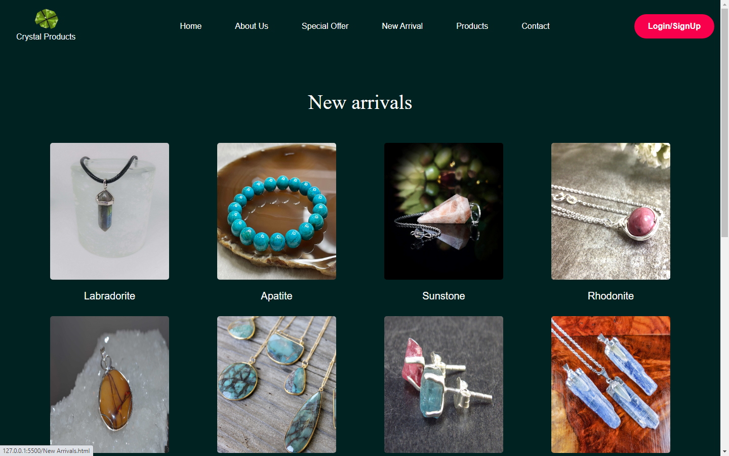

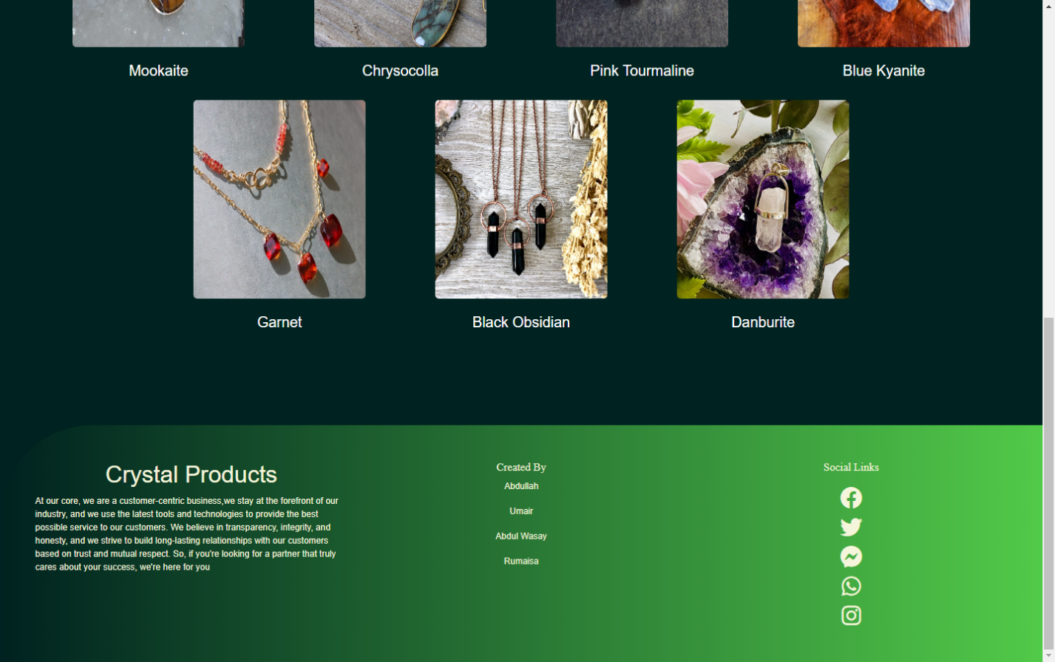

Products

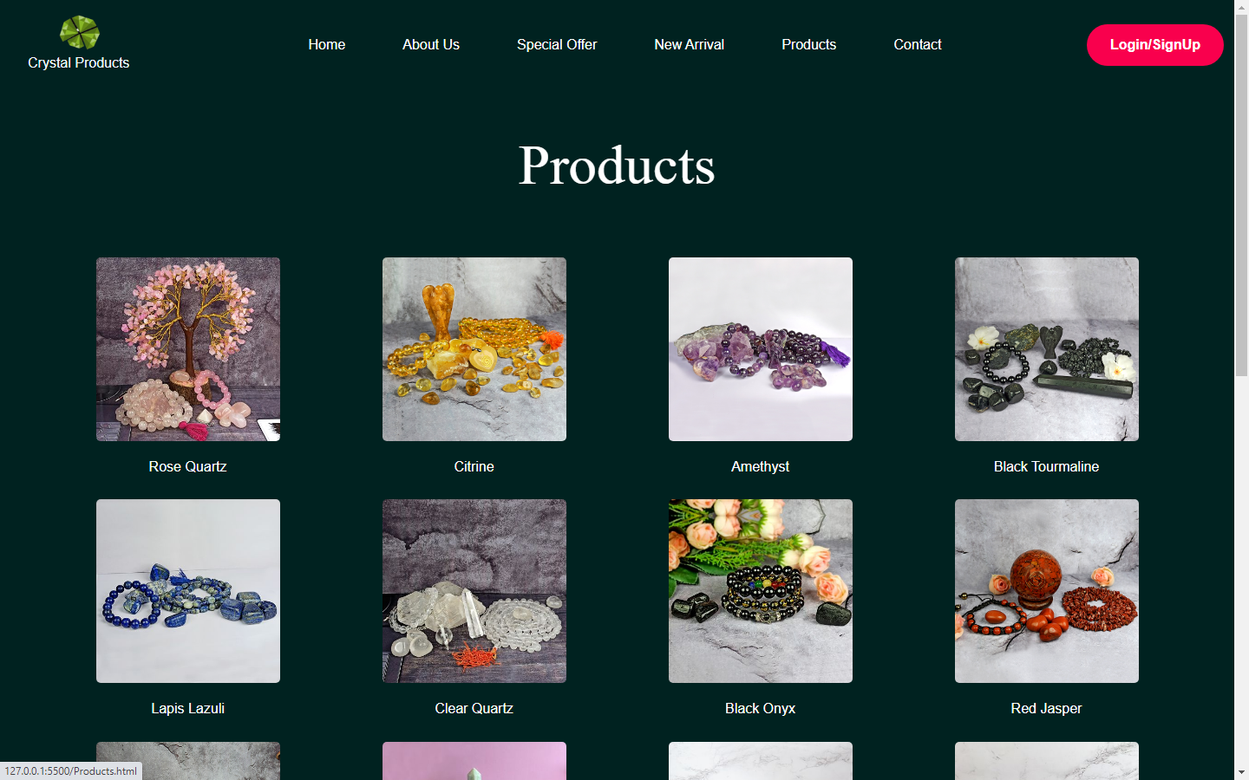

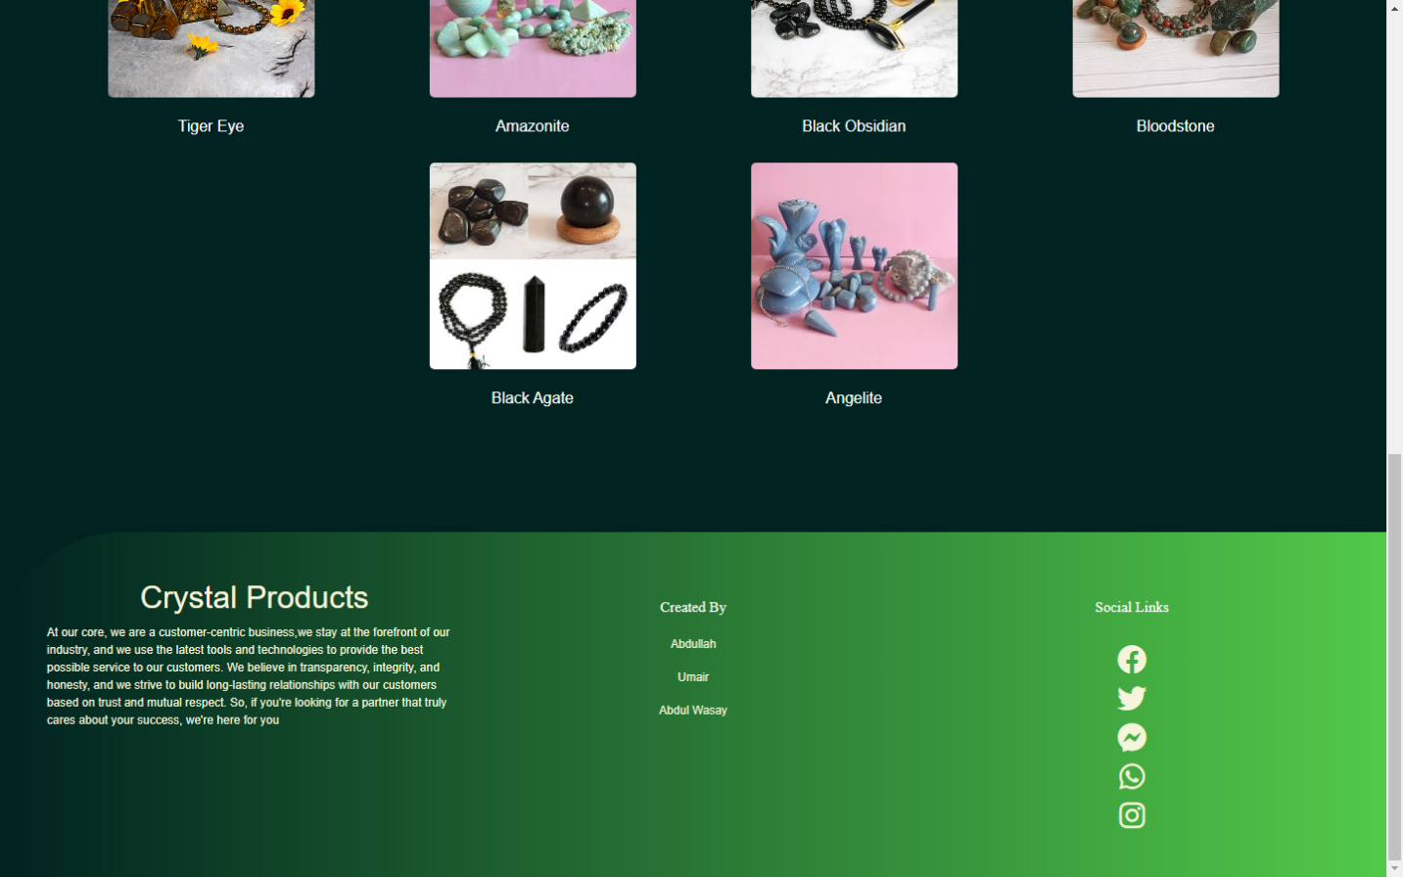

Contact Us

